**Welcome:**

Carlingford Netball Club Incorporated welcomes you to the 2025 Winter Netball Season.

For those who are new to our club we extend a special welcome, and for those who are old hands, welcome back for another season! We hope that your child enjoys the experience of playing Netball and that as parents, you also share the enjoyment of participating in your child’s sport and meeting other families from across our wonderful community.

Please take time to read through this document as it contains important information for the season ahead.

We wish you a great season with us at Carlo and please get back to us with any questions!

**Team Announcement:**

Thank you for registering to play for Carlingford Netball Club during the 2025 Winter Season.

We are pleased to announce your team as follows:

|  |  |  |  |
| --- | --- | --- | --- |
| **Grade:** |  | **Team Name:** |  |
| **Coach:** |  | **Manager:** |  |

|  |  |  |  |
| --- | --- | --- | --- |
| **Players:** | Xxx | Xx | xx |
| Xx | Xx | Xx | xx |
| Xx | Xx | Xx | xx |

A Team WhatsApp group should already have been setup for all team communications.

**Training Commitment:**

Training is held weekly at our home courts at [**Don Moore Reserve, North Rocks**](https://www.cityofparramatta.nsw.gov.au/our-parks/don-moore-reserve)**.** The club hires courts throughout the season from the City of Parramatta on Wednesday, Thursday and Friday evenings.

Your team has been allocated the following training day and time:

|  |  |
| --- | --- |
| **Wednesday or Thursday** |  |

**Team training is an important part of Netball and helps to grow and improve your child’s skills and game.**

We **strongly** suggest that **all players** attend the team’s weekly training session, wearing appropriate clothing and footwear. If, due to illness, injury or unavoidable factors, you are unable to attend a training session, please respect your Coach, Manager and team mates by notifying your Coach and Manager as far in advance as possible.

In the event of wet weather, training is held at the discretion of your Coach – please assume that training will be held, unless otherwise advised through your WhatsApp.

**Winter Competition Information:**

Carlingford Netball Club is part of the [**Hills District Netball Association (HDNA)**](https://www.hdnanetball.com.au/). Fixtures can be accessed via [**PlayHQ**](https://www.playhq.com/netball-australia/org/carlingford-netball-club/cad776c4) and by downloading the NetballHQ App. The 2025 Winter Competition commences in May!

All games are played locally at the **HDNA Netball Courts**, located at **Britannia Street, Pennant Hills.** Parking is located above the Netball courts, along the driveway and adjacent to the Hockey Courts.

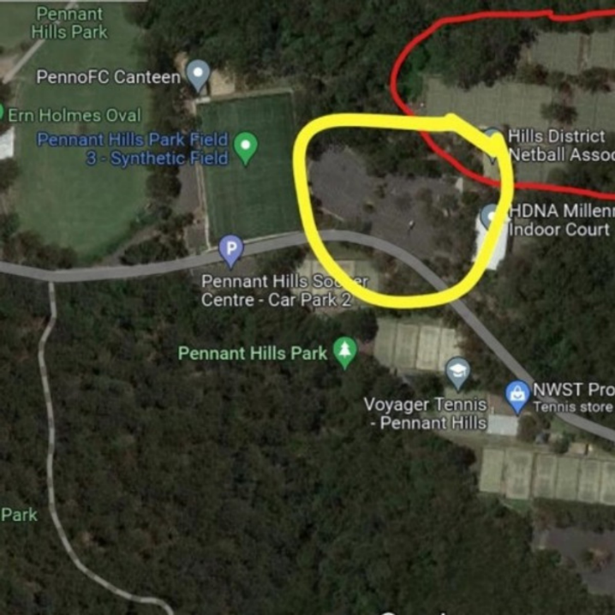

Parents are strongly encouraged to plan holidays around their Winter netball commitments where possible.  Coaches and Managers must be advised of any absences so the team can always play with a full complement to make the most of their playing experience.

|  |  |
| --- | --- |
| **Hills District Netball Association 2025 Winter Netball Season** | |
| Round 1 | Friday May 2 (Set & GO) and Saturday May 3 (Under 10’s to Seniors) |
| Round 2 | Friday May 9 (Set & GO) and Saturday May 10 (Under 10’s to Seniors) |
| Round 3 | Friday May 16 (Set & GO) and Saturday May 17 (Under 10’s to Seniors) |
| **Round 15** | **Friday May 23 – Various Junior and Cadet teams – Divisions with 6 teams only** |
| Round 4 | Friday May 23 (Set & GO) and Saturday May 24 (Under 10’s to Seniors) |
| Round 5 | Friday May 30 (Set & GO) and Saturday May 31 (Under 10’s to Seniors) |
|  | **No Games – Friday June 6 and Saturday June 7** |
| Round 6 | Friday June 13 (Set & GO) and Saturday June 14 (Under 10’s to Seniors) |
| Round 7 | Friday June 20 (Set & GO) and Saturday June 21 (Under 10’s to Seniors) |
| Round 8 | Friday June 27 (Set & GO) and Saturday June 28 (Under 10’s to Seniors) |
|  | **No Games – Friday July 4 and Saturday July 5, Friday July 11 and Saturday July 12** |
| Round 9 | Friday July 18 (Set & GO) and Saturday July 19 (Under 10’s to Seniors) |
| Round 10 | Friday July 25 (Set & GO) and Saturday July 26 (Under 10’s to Seniors) |
| Round 11 | Friday August 1 (Set & GO) and Saturday August 2 (Under 10’s to Seniors) |
| Round 12 | Friday August 8 (Set & GO) and Saturday August 9 (Under 10’s to Seniors) |
| Round 13 | Friday August 15 (Set & GO) and Saturday August 16 (Under 10’s to Seniors) |
| Round 14 | Friday August 22 (Set & GO) and Saturday August 23 (Under 10’s to Seniors) |
| Semi Final | Saturday August 30 (Under 10’s to Seniors) |
| Preliminary Final | Saturday September 6 (Under 10’s to Seniors) |
| Grand Final | Saturday September 13 (Under 10’s to Seniors) |

|  |  |
| --- | --- |
| **Playing Time** | **Carlingford Teams** |
| Friday 6.15pm | GO – ? SET – ? |
| **Friday May 23 - 6pm** |  |
| **Friday May 23 – 7pm** |  |
| **Friday May 23 – 8.15pm** |  |
| Saturday 8.15am |  |
| Saturday 9.30am |  |
| Saturday 10.45am |  |
| Saturday 12.00pm |  |
| Saturday 1.15pm |  |
| Saturday 2.30pm |  |

Please arrive at least **30 minutes** prior to your playing time unless advised otherwise by your Coach/Manager.

**Uniform:**

We offer inclusive uniform and includes the options of:

* Carlingford Jade Green & Navy Blue Dress
* Navy Boyleg Briefs (to be worn underneath the dress)

or black leggings under dress (any brand as long as branding is not visible).

* A green and blue sports shirt

  Description automatically generatedCarlingford Socks A blue shorts with a white logo

  Description automatically generated

OR

* Carlingford Jade Green & Navy Blue Short Sleeve T-shirt
* Navy or Black Playing “Mesa Hero” Shorts
* Carlingford Socks

​

Players may wear a mixture of dresses and t-shirts and during winter, a long sleeve white t-shirt can also be worn under either the dress or t-shirt to stay warm!

**Players must have the playing uniform in preparation for Round 1, commencing 3rd and 4th May!**

​

Carlingford Netball Club encourages players to purchase the following new or second hand additional uniform items:

* Carlingford Navy Jacket
* Carlingford Blue/Green Hair Ties

​

Uniforms can be purchased through our new supplier, Team Kit [**https://teamkit.shop/collections/carlingford-netball-club**](https://teamkit.shop/collections/carlingford-netball-club) or by email to [**carlonetball@gmail.com**](mailto:carlonetball@gmail.com).

​

A limited number of second hand uniform items will also be advertised at our PlayHQ registration page or through Our Uniform page, in addition to posts found within our Annual Second Hand Uniform post on the [**Carlingford Netball Club Facebook Page**](https://www.facebook.com/carlonetball/).

​

For all competition games, HDNA requires the consistent use of the club uniform for each team.

* Low cut socks or socks with logos are not permitted.
* **All jewellery (including body piercings) must be removed** before taking the court and **fingernails must be short and filed.**
* Please consider getting new piercings after the netball season ends as Umpires cannot allow players with any type of jewellery on court.

**Our new Training Shirts** need to be worn to each game for player to warm up in. These can be worn over the top of the dress and be taken off prior to the commencement of the game. Please watch this space for more information!

**What happens when it’s been raining – do we still have to play and train?**

Games at Pennant Hills are played on an all-weather surface designed to quickly dry and pool rainwater away from the court. HDNA will advise each club if conditions are unsafe for play in advance and we will let your Manager know if play is called off. **Always assume that you are playing each week unless advised otherwise!**

Training at Don Moore Reserve is also held on a new, all weather surface. In the event of wet weather, training will be held at the discretion of your Coach but please assume that training is on, unless otherwise advised through your Team WhatsApp group.

**How involved do I have to be as a parent?**

You can be as involved as much as you choose but please appreciate that the club is run by volunteers who

give up many hours of their free time to make sure your child makes the most of the Netball season. Unlike other sports, Netball requires parent participation so that a team can run effectively. We asked parents to assist with scoring duties or when it’s our club’s turn to manage other duties at Pennant Hills.

**Coaching & Team Management**

Coaches, Managers and Umpires are the people who keep our club, and HDNA running smoothly.

Carlingford Netball Club is always looking for interested players, parents or community members to take up Coaching or Manager roles - all we need from you is a Working with Children Check (through Service NSW).

If you would like to take on a team coach or manager role, we will provide all the necessary support to take on these vital positions. **We will also cover the cost of the NSW Foundation Coaches Course and other programs such as the NetSetGO Coaching Development Course to help assist your coaching journey.**

Please contact us at [**carlonetball@gmail.com**](mailto:carlonetball@gmail.com) to chat about your interest and what might be possible. We would love to hear from you!

**How does our Club communicate with members?**

During the season, Carlingford Netball Club publishes its E-newsletter “Off the Court” twice a month

which is sent directly to member email addresses on Thursday evening or Friday mornings.

We also communicate weekly via our Facebook and Instagram pages which offers an update on all things Netball related throughout the season, including match results, club announcements, team pictures and video clips, awards and lots more. Please join us at [**https://www.facebook.com/carlonetball**](https://www.facebook.com/carlonetball)

Your team manager will also setup a WhatsApp group for each team which is used for club information, competition updated, advice of player illness and various updates throughout the season.

**Any further questions?**

Please email us at **carlonetball@gmail.com** or contact Belinda Turco on 0405 453 578.

We wish you all the very best for the 2025 Winter Netball season!